- Which social media platform (Twitter, Instagram, or Facebook) is the most effective method of advertising in each country? (In this case, consider the total number of lead conversions as a measure of effectiveness).

WITH channel_conversions AS (
SELECT
m."Country",
'Twitter' AS channel,
SUM(a.twitter_ad) AS total_conversions
FROM marketing_data m
JOIN ad_data a
ON m."ID" = a.id
GROUP BY m."Country"

UNION ALL

SELECT
m."Country",
'Instagram' AS channel,
SUM(a.instagram_ad) AS total_conversions
FROM marketing_data m
JOIN ad_data a
ON m."ID" = a.id
GROUP BY m."Country"

UNION ALL

SELECT
m."Country",
'Facebook' AS channel,
SUM(a.facebook_ad) AS total_conversions
FROM marketing_data m
JOIN ad_data a
ON m."ID" = a.id
GROUP BY m."Country"

UNION ALL

SELECT
m."Country",
'Bulkmail' AS channel,
SUM(a.bulkmail_ad) AS total_conversions
FROM marketing_data m
JOIN ad_data a
ON m."ID" = a.id
GROUP BY m."Country"

UNION ALL

SELECT
m."Country",
'Brochure' AS channel,
SUM(a.brochure_ad) AS total_conversions
FROM marketing_data m
JOIN ad_data a
ON m."ID" = a.id
GROUP BY m."Country"
),
ranked AS (
SELECT
"Country",
channel,
total_conversions,
ROW_NUMBER() OVER (
PARTITION BY "Country"
ORDER BY total_conversions DESC, channel
) AS rn
FROM channel_conversions
)
SELECT
"Country",
channel AS most_effective_channel,
total_conversions
FROM ranked
WHERE rn = 1
ORDER BY "Country";
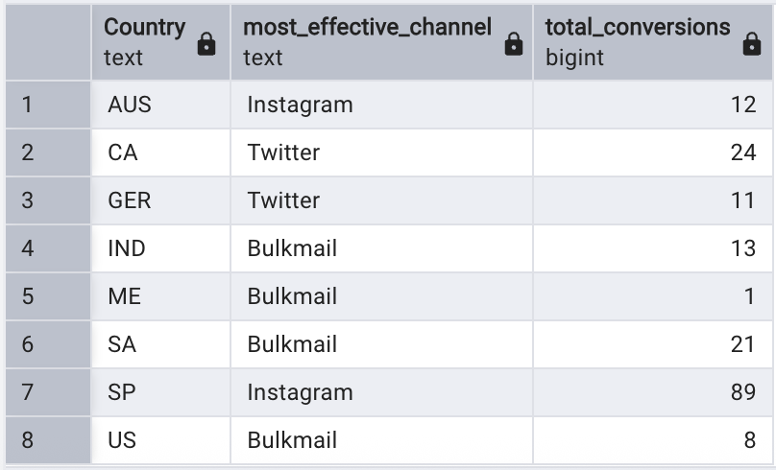
- Which social media platform is the most effective method of advertising based on marital status? (In this case, consider the total number of lead conversions as a measure of effectiveness).
WITH platform_conversions AS (
SELECT
m."Marital_Status",
'Twitter' AS platform,
SUM(a.twitter_ad) AS total_conversions
FROM marketing_data m
JOIN ad_data a
ON m."ID" = a.id
GROUP BY m."Marital_Status"

UNION ALL

SELECT
m."Marital_Status",
'Instagram' AS platform,
SUM(a.instagram_ad) AS total_conversions
FROM marketing_data m
JOIN ad_data a
ON m."ID" = a.id
GROUP BY m."Marital_Status"

UNION ALL

SELECT
m."Marital_Status",
'Facebook' AS platform,
SUM(a.facebook_ad) AS total_conversions
FROM marketing_data m
JOIN ad_data a
ON m."ID" = a.id
GROUP BY m."Marital_Status"

UNION ALL

SELECT
m."Marital_Status",
'Bulkmail' AS platform,
SUM(a.bulkmail_ad) AS total_conversions
FROM marketing_data m
JOIN ad_data a
ON m."ID" = a.id
GROUP BY m."Marital_Status"

UNION ALL

SELECT
m."Marital_Status",
'Brochure' AS platform,
SUM(a.brochure_ad) AS total_conversions
FROM marketing_data m
JOIN ad_data a
ON m."ID" = a.id
GROUP BY m."Marital_Status"
),
ranked AS (
SELECT
"Marital_Status",
platform,
total_conversions,
ROW_NUMBER() OVER (
PARTITION BY "Marital_Status"
ORDER BY total_conversions DESC
) AS rn
FROM platform_conversions
)
SELECT
"Marital_Status",
platform AS most_effective_platform,
total_conversions
FROM ranked
WHERE rn = 1
ORDER BY "Marital_Status";

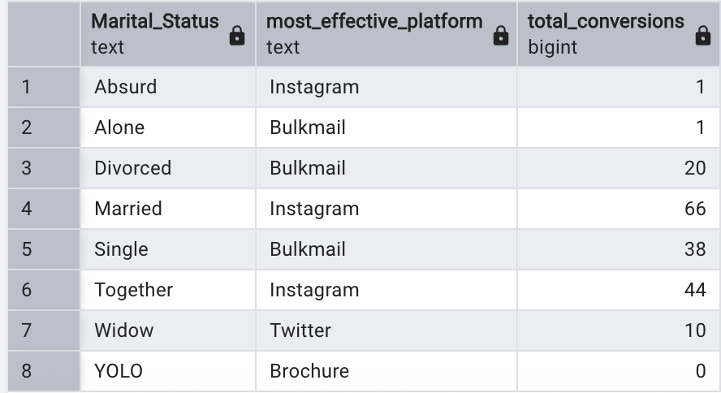

Which social media platform(s) seem(s) to be the most effective per country? (In this case, assume that purchases were in some way influenced by lead conversions from a campaign). Hint: You’ll want to generate the amount spent per product type per country and include a total of the ads for each of the social media platforms. Then, review the output to determine whether there is anything interesting related to the amount spent per product in each country and which social media platforms were used for advertising.
SELECT
m."Country",

/* Product spend */
SUM(m."AmtLiq") AS liquor_spend,
SUM(m."AmtVege") AS vegetable_spend,
SUM(m."AmtNonVeg") AS nonveg_spend,
SUM(m."AmtPes") AS fish_spend,
SUM(m."AmtChocolates") AS chocolate_spend,
SUM(m."AmtComm") AS commodity_spend,

/* Social media lead conversions */
SUM(a.twitter_ad) AS twitter_conversions,
SUM(a.instagram_ad) AS instagram_conversions,
SUM(a.facebook_ad) AS facebook_conversions

FROM marketing_data m
JOIN ad_data a
ON m."ID" = a.id
GROUP BY m."Country"
ORDER BY m."Country";
